Persons completing this assessment should refer to the UCD Chemical Safety Manual and the UCD Biosafety Manual if appropriate

- General Information

Name of Person(s) involved in the process and their position
Principal Investigator / Supervisor (Person responsible for ensuring safety)
Location of work
Date of Assessment
Duration and frequency of procedure

- Title and Details of the Process - Provide details of objectives, equipment used, method, SOP’s and additional information can be attached as required. For chemicals and biological agents, please describe the entire lifecycle of usage from delivery to disposal. Include details of any hazardous reaction products or wastes generated and how these are to be managed.

Title of Procedure/experiment:
Details:

- Hazard Identification and Risk Assessment

To complete the Risk Assessment Form below:
- Identify the hazards in undertaking this experiment
- Evaluate the associated risks and consider who might be harmed and how, including any persons with health problems or lacking experience who may be at greater risk.
- List control measures to reduce the risk - procedures, equipment, training etc.
- Establish the residual risk rating after the implementation of controls

Risk Rating = Likelihood of risk occurring x Severity of outcome

Assessment of Likelihood and Severity

- Trivial Risk: No further action needed
- Acceptable Risk: No additional risk control measures required
- Moderate Risk: Implement further risk control measures if possible
- Substantial Risk: Further control measures must be implemented. If this is not possible then work must be strictly managed to ensure safety.
- Intolerable: Work must be prohibited until further control measures are implemented.

CHEMICAL AND BIOLIGICAL HAZARD SECTIONS ARE BELOW THIS TABLE

Hazard |  |  |  | Risk(s) | Control Measure(s)
- Physical hazards
(e.g. manual handling, slips/trips, poor housekeeping, working in hot/cold environments, fire)
Residual Risk Rating:
- Health hazards
(e.g. noise, dust, fumes, vibrations, working in poor light)

Residual Risk Rating:
- Equipmment hazards
(e.g. centrifuges, autoclaves, ULT freezers, gel rigs, power packs, water baths, pH meters, plant growth rooms/chambers etc)
Residual Risk Rating:
- Waste hazards
(e.g. waste streams)

Residual Risk Rating:

CHEMICAL HAZARDS
(copy and paste this table for each hazardous chemical used in the process)

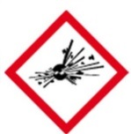  GHS01 | 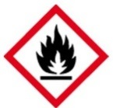  GHS02 | 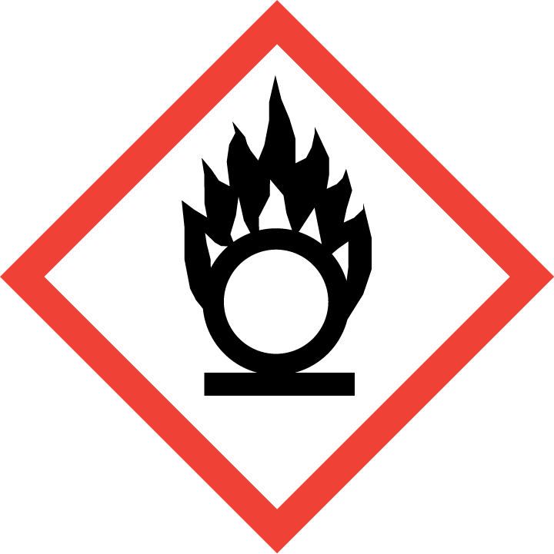  GHS03 |  | GHS04   |  | 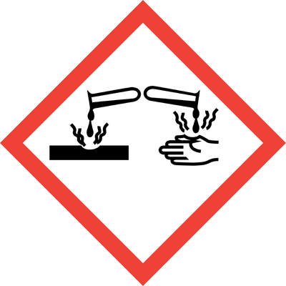  GHS05 | 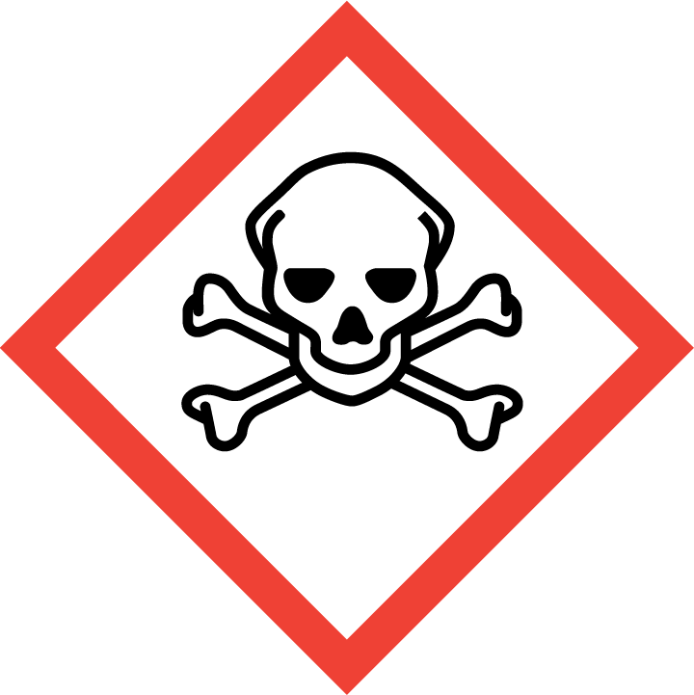  GHS06 |   GHS07 |  |   GHS08 | GHS09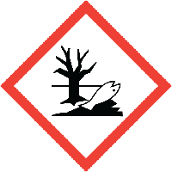
☐ | ☐ | ☐ |  |  | ☐ | ☐ | ☐ | ☐ |  | ☐ | ☐
Chemical name |  |  |  |  |  | Hazard Statements
Hazard Class
Signal Word |  |  |  |  |  | Precautionary Statements
Amount
Form

Provide scientific justification for the use of chemicals classed as Carcinogen, Mutagen or Reproductive Toxin
____________________________________________________________________________________________________________________________________________________________________

Are any of the chemicals in use incompatible and likely to give rise to a potentially dangerous reaction or generate hazardous reaction products (give details): __________________________________________________________________________________
Check potential reactions with the Chemical Reactivity Worksheet

Location of SDS for each Chemical: _____________________________________________________

Chemical wastes Generated

GHS01 | GHS02 | GHS03 | GHS04 |  | GHS05 | GHS06 | GHS07 | GHS08 | GHS09
☐ | ☐ | ☐ |  | ☐ | ☐ | ☐ | ☐ | ☐ | ☐
(Add additional tables as required)

Potential Chemical Exposure*

- Who (and how many) could potentially be exposed to these chemicals. Consider all stages of the chemicals’ lifecycle from delivery through to disposal.
- Is there a part of the process which could lead to a release of the chemical into the air or onto a surface (give details)?
What controls are in place to prevent this?
- What are the potential routes of exposure? (Inhalation, ingestion, dermal, transplacental, sharps)
- What steps have you taken to minimise or eliminate the potential routes of exposure identified?
- What is the chance of the exposure occurring? (Unlikely, Likely, Very Likely)
- Concentration / intensity, duration and frequency of exposure
* for carcinogens, mutagens and reproductive toxins the objective should be to eliminate exposure

Chemical Controls in Place
- PPE in use | Lab Coat: ☐ Safety Glasses: ☐  Safety Goggles: ☐ Face Shield: ☐ Gloves: ☐ (indicate type)____________  Other: ☐ (give details) _____________
- Engineering controls | Fume hood: ☐ Other: : ☐  * LEV/Snorkel : ☐  * only suitable for low risk activities involving low risk materials.
- Other controls
- Storage arrangements (ensure incompatibles are separated)
- Waste disposal procedure

Further Risk Control Measures for Chemicals These additional risk control measures should be designed to tackle the hazards identified in Sections 3, 4, 5, and 6 above. All questions must be answered.
- Can any of the hazardous agents be replaced with less hazardous materials? (give details)
- Can the amount of chemical in use be reduced?
- Can the duration / intensity of exposure / numbers of persons exposed be reduced?
- Is warning signage required?
- Are transport or storage arrangements contributing to risk?
- Is appropriate first aid equipment / antidotes available?
- In the case of carcinogens, mutagens and reproductive toxins are storage and labelling provisions adequate?
- In the case of carcinogens, mutagens and reproductive toxins can a sealed working system be used?
- In the case of carcinogens, mutagens and reproductive toxins does the working area require demarcation?
- In the case of carcinogens, mutagens and reproductive toxins do the users require medical surveillance?
- Is further training for personnel required?
- Is occupational exposure monitoring required?

Chemical Emergency Responses (Consult relevant SDS for further information)

 | Response Measures | Location of kits / specialist or response equipment
- Fire
- First Aid
- Accidental Release / Spill Response

BIOLOGICAL AGENT HAZARDS
Detail potential infectious agents that persons may be exposed to:
________________________________________________________________________________________________________________________________________________________________________________________________________________________________________________________________________________________________________________________________________

What training is required before work with biological agents commences? (note the person named in Part 1 as being responsible for ensuring safety must ensure that this training is provided).

Details:

Potential Exposure to Biological Agents

- Who (and how many) could potentially be exposed to these biological agents?
- What are the potential routes of exposure? (e.g. Ingestion, inhalation, needle stick, direct skin / clothing contamination)
c) What are the potential health effects of
these biological agent(s)

Biological Agent Controls in Place

- PPE in use | Lab Coat: ☐ Safety Glasses: ☐  Safety Goggles: ☐ Face Shield: ☐ Gloves: ☐ (indicate type)_______________  Other: ☐ (give details) ________________
- Engineering controls | Biological Safety Cabinet: ☐  Other: _________________(Give details)
- Storage arrangements
- Waste disposal procedure

Further Risk Control Measures for Biological Agents- Consider further risk control measures required to eliminate / minimise identified routes of exposure and allow the safe use of agents.

Where deemed necessary provide details of the following additional control measures:
- Design of work practices to minimise potential for contact with biological agents
- The display of warning signage in the work area
- Plans to deal with accidents involving a biological agent
- Testing for the presence of a biological agent outside of the primary physical confinement

Biological agent emergency Responses

 | Response Measures | Location of kits / specialist or response equipment
- First Aid
- Accidental Release / Spill Response
- Suitable Disinfectant

Is the risk rating acceptable: Yes: ☐ No: ☐
If yes sign and date below and ensure all risk control measures have been implemented.
If no identify further control measures and reassess risk. If the risk cannot be reduced to an acceptable level then the process cannot be carried out.

Is this work suitable for lone working: Yes: ☐ No: ☐

If certain parts of the process are suitable for lone working indicate them below:
________________________________________________________________________________________________________________________________________________________________________________________________________________________________________________________________________________________________________________________________________

Signed: Date: Position:

________________ __________ ________________

Signed: Date: Position:

________________ ___________ ________________

This document must be signed by the person carrying out the assessment and their academic supervisor / manager (person responsible for ensuring safety).

